Quality 4.0 Benchmarking Platform
Co-creation Workshop
October 21st, 2026, University of Finance and Administration
Estonská 500, Prague, Czech Republic
09:00 |  | Part I. Opening and Platform Inputs
 | 09:00 | Dr. Renáta Janošcová, PhD. University of Finance and Administration, Czech Republic  Opening and Objectives
 | 09:10 | Assoc. Prof. Ágota Drégelyi-Kiss, PhD. Óbuda University, Hungary  Quality 4.0 Maturity Model
 | 09:30 | Prof. Sławomir Wawak, Krakow University of Economics, Poland  Quality 4.0 Maturity Self-Assessment Tool
 | 09:50 | Dr. David Vykydal, Technical University of Ostrava, Czech Republic  From Assessment to Benchmarking
 | 10:10 | Dr. Andrea Sütőová, Technical University of Ostrava, Czech Republic  Recommendations and Case Studies Structure
10:30 |  | Coffee break
11:00 |  | Part II. Interactive Platform Design
 | 11:00 | Interactive Brainstorming  Platform Architecture & Key Components
 | 11:45 | Interactive Brainstorming  Platform Functionalities & Benchmarking Logic
12:30 |  | Lunch
 | 13:00 | Interactive Brainstorming  User Experience & User Journey
 | 14:00 | Interactive Brainstorming  Data Visualisation & Dashboard Design
15:00 |  | Coffee break
 | 15:15 | Interactive Brainstorming  Case Studies Integration & Practical Validation
 | 16:00 | Discussion (Prioritization & Next Steps)
16:30 |  | Closing the seminar

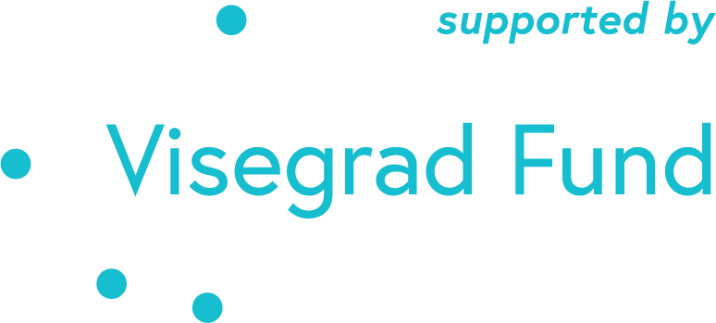 |  | 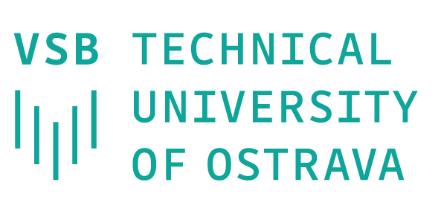 |  | 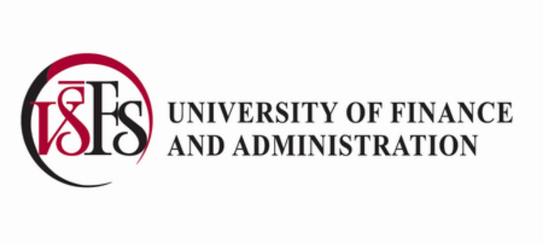
The Co-creation Workshop is co-financed by the Governments of Czechia, Hungary, Poland, and Slovakia through Visegrad Grants from International Visegrad Fund. The mission of the fund is to advance ideas for sustainable regional cooperation in Central Europe.

