

Title of Bachelor’s thesis

Bachelor’s thesis

Author of the thesis: Full name
Supervisor: Full name and academic titles

Ostrava (year of submission) 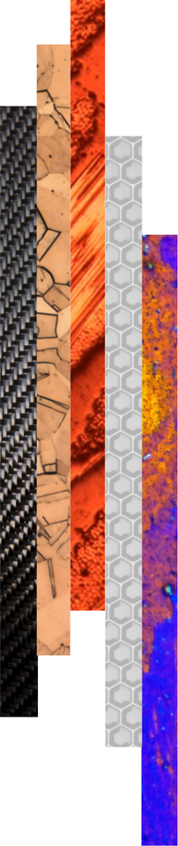

Bibliographic record
Author: Academic title, first name and surname
Title of the thesis: Title of the Bachelor’s thesis
Study programme: Code and name of the study programme (e.g. B0719A270003 Materials Engineering)
Supervisor: First name and surname, including academic titles
Academic year: 2025/2026
Number of pages:
(PLACE FOR THE BACHELOR’S THESIS ASSIGNMENT – DELETE THIS TEXT)

ACKNOWLEDGEMENTS

ABSTRACT
The abstract provides a concise summary of the main content, objective, applied methods, and achieved results of the bachelor’s thesis. It clearly defines the problem addressed and states the primary aim of the work. It briefly describes the chosen methodology or approach used to fulfil the defined objective.
The abstract also includes a summary of the key findings and their practical or professional relevance. It offers a quick and clear overview of the essence of the thesis, its main conclusions, and its significance for the topic addressed.
The abstract typically has a length of 80–100 words. The text is concise, factual, and does not contain unnecessary details.
Keywords: (4-5 keywords)

CONTENT
1 Introduction 8
2 Analysis of the current state of knowledge 9
3 Objectives of the bachelor´s thesis 10
4 Title of the first chapter 11
4.1 Title of the subchapter 11
4.2 Title of the subchapter 11
4.2.1 Title of the sub-subchapter 12
4.2.2 Title of the sub-subchapter 12
5 Discussion 13
6 Conclusion 14
7 References 15
8 List of appendices 16

LIST OF ABBREVIATIONS AND SYMBOLS
Symbol | Unit | Description

LIST OF TABLES AND FIGURES
Number | Table/Figure Title | Page

INTRODUCTION
This template is designed to facilitate the preparation of a bachelor´s thesis and to ensure a uniform formal layout of final theses at the Faculty of Materials Sicence and Technology, VSB – Technical University of Ostrava. The final appearance of the thesis, including its structure, formatting, and linguistic quality, together with the correct use of professional terminology and adherence to grammatical standards, forms an integral part of the overall assessment of the bachelor´s thesis and its defence.
The bachelor´s thesis must be prepared with a minimum length of 35 pages. The requirements for the preparation of the bachelor’s thesis are specified in the Guidelines for the preparation of the bachelor’s thesis, which are available on the FMT website under Study regulations and forms
The following text uses the Normal style. If left-aligned text without first-line indentation and with spacing between paragraphs is preferred, the Left-aligned Normal style may be used. Hyphenation is not enabled in this template.
The introduction of a bachelor´s thesis defines the basic framework and academic context of the addressed topic. It provides a justification for choosing the topic and explains its relevance with respect to current knowledge or practical applications. The introduction includes the formulation of the main objective of the bachelor´s thesis and a brief overview of existing findings or approaches relevant to the topic. It also presents the theoretical background on which the thesis is built and outlines the expected contribution of the work to the investigated problem or its potential practical use.
The structure of the bachelor´s thesis provided in this template represents a recommended organisation of the text. Individual chapters and subchapters may be modified, expanded, or supplemented depending on the nature of the topic.

Analysis of the Current State of Knowledge
This chapter summarizes the fundamental knowledge and information available on the topic addressed in the bachelor’s thesis and thus provides a literature review of relevant sources. It focuses on an overview of theoretical concepts, published studies, and practical approaches related to the researched issue.
The chapter also includes a brief analysis of existing approaches and their contributions or limitations. This analysis helps to define the scope of the investigated problem and shows the context in which the subsequent work will be carried out.
This part serves as the theoretical foundation for the practical or analytical section of the bachelor’s thesis and enables the subsequent results and conclusions to be placed within a broader academic context.
Figures, tables, charts, and equations must be numbered consistently and clearly throughout the thesis. Each of these elements must be accompanied by an appropriate description (caption, title, or legend) to ensure their unambiguous identification in the text. Recommended formatting for tables, figures, and equations is provided below.

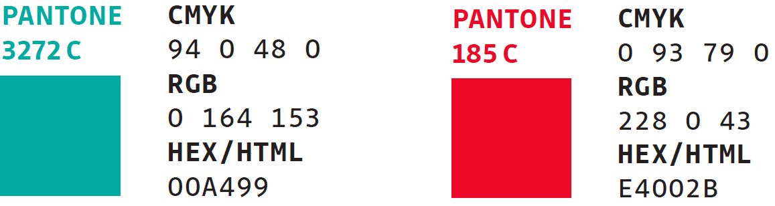
Obr. 1 RGB codes for the colour scheme of the VSB-TUO visual identity.

$$f\left(x\right)=a_{0}+\sum_{n=1}^{∞}{\left(a_{n}\cos{\frac{nπx}{L}}+b_{n}\sin{\frac{nπx}{L}}\right)}$$ | (1)
$${\left(x+a\right)}^{n}=\sum_{k=0}^{n}{\left({n \atop k}\right)x^{k}a^{n-k}}$$ | (2)

Tab. 1 Description of the table.

Objectives of the Bachelor´s thesis
This chapter formulates the main and, where applicable, partial objectives of the bachelor´s thesis, which define the direction for addressing the assigned topic. The objectives are stated clearly, specifically, and logically so that their fulfilment can be unambiguously evaluated. The main objective expresses the overall focus and expected outcome of the thesis, while the partial objectives represent the individual steps or stages required to achieve it.

Title of the First Chapter
The following chapters constitute the main technical and scholarly part of the bachelor´s thesis. The first chapter typically describes the materials and methods used, providing a clear overview of the selected procedures, experimental techniques, analytical methods, or computational tools applied to address the given problem.
The methodological section is followed by a chapter presenting the results achieved. This part contains logically structured outputs of the experiments or analyses, supplemented with appropriate graphs, tables, or figures that clearly illustrate the main findings.
If necessary, additional subchapters may be included to ensure that the topic is covered with appropriate scope and coherence.

Title of the subchapter
This part of the bachelor´s thesis elaborates on another specific aspect related to the addressed topic. The text should be structured with an emphasis on logical continuity and a clear connection to the overall objectives of the thesis, while its specific content and scope reflect the nature of the topic and the chosen approach to its solution.

Title of the subchapter
This part of the bachelor´s thesis provides a more detailed elaboration of a selected area related to the topic, closely linked to the objectives and the chosen methodology. The text should include a description of the principles, approaches, and procedures applied in addressing the given issue.
If necessary, the chapter may be further divided into subchapters (e.g., 4.2.1, 4.2.2), focusing on specific aspects of the topic, theoretical foundations, experimental setup, or data analysis. Each subchapter should be written clearly and maintain logical continuity with the preceding part of the text.

Title of the sub-subchapter
This section provides a more detailed elaboration of a specific aspect of the topic discussed in the preceding subchapter.
The text should be written clearly, logically, and factually, with an emphasis on the coherence of the individual parts of the thesis and on clearly explaining the relationships between the theoretical background, the chosen methodology, and the obtained results. All referenced findings, data, equations, and figures must be properly cited in accordance with citation standards and accompanied by appropriate source references. It is also advisable to use tables, graphs, or illustrations that support the interpretation and facilitate a comprehensive understanding of the presented information.

Title of the sub-subchapter
This section provides a more detailed elaboration of a specific aspect of the topic discussed in the preceding subchapter.
The text should be written clearly, logically, and factually, with an emphasis on the coherence of the individual parts of the thesis and on clearly explaining the relationships between the theoretical background, the chosen methodology, and the obtained results. All referenced findings, data, equations, and figures must be properly cited in accordance with citation standards and accompanied by appropriate source references. It is also advisable to use tables, graphs, or illustrations that support the interpretation and facilitate a comprehensive understanding of the presented information.

Discussion
This chapter interprets the achieved results and places them within the context of current knowledge in the field. It includes an evaluation of the obtained data, their comparison with relevant academic literature, and an explanation of the main trends or phenomena arising from the results. The discussion focuses on clarifying the significance of the findings for the addressed topic.
This chapter also includes a brief assessment of the methods used, potential limitations of the data, and factors that may have influenced the interpretation of the results. Furthermore, the discussion explains how the findings relate to the defined objectives of the bachelor´s thesis and outlines their practical or academic relevance.

Conclusion
This chapter provides a concise and clear summary of the main results of the bachelor´s thesis and evaluates the extent to which they fulfil the defined objectives. The introductory part of the chapter offers a brief overview of the most important findings, followed by a structured presentation of the key conclusions arising from the work.
The chapter also includes an assessment of the contribution of the results to the relevant field or to practical applications, as well as to the further development of the addressed topic. The text is written in a factual and well-structured manner, ensuring logical continuity with the preceding chapters and providing a comprehensive evaluation of the significance of the achieved findings.

REFERENCES
All cited sources (including electronic resources) are listed here in accordance with the ISO 690 standard. Every referenced item must also appear directly in the text, including citations placed under reproduced figures, graphs, or tables, either in square brackets or using the author–year format as specified by ISO 690 (e.g. https://www.iso690.zcu.cz/).
The bachelor´s thesis must include at least 10 bibliographic references, of which a minimum of 3 must be in a foreign (world) language.

- First citation of the referenced source as indicated in the document.
- Second citation of the referenced source as indicated in the document.
- Third citation of the referenced source as indicated in the document.

List of Appendices
Appendix A: Description/title of the appendix.
Appendix B: Description/title of the appendix.

(If appendices are part of the dissertation, they must be submitted in a separate document. If the dissertation does not include any appendices, this chapter is not included.)

