

Title of Dissertation thesis

Discussion on the dissertation thesis proposal

Author of the thesis: Full name and academic title
Supervisor: Full name and academic titles

Ostrava (year of submission) 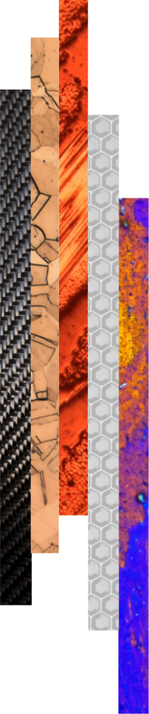
ANNOTATION OF DISSERTATION THESIS
The annotation provides a concise summary of the dissertation thesis. It outlines the main research objectives, defining the focus and expected contributions of the study, followed by a brief description of the methodology applied to achieve these objectives. It also presents the key results obtained from the conducted research and an evaluation of the contribution of the work to the advancement of the relevant scientific field as well as to its potential practical applications.
Keywords: (5-7 keywords)

CONTENTS
1 Introduction 4
2 Analysis of the current state of knowledge 5
3 Objectives of the dissertation thesis 6
4 Research methodology 7
5 Achieved results 8
5.1 Title of the subchapter 8
5.1.1 Title of the sub-subchapter 8
5.2 Title of the subchapter 9
5.2.1 Title of the sub-subchapter 9
5.2.2 Title of the sub-subchapter 9
6 Discussion 10
7 Conclusion 11
7.1 Contribution for scientific field 11
7.2 Contribution for practice 11
8 References 13
9 List of own publications 14
10 List of appendices 15

LIST OF ABBREVIATIONS AND SYMBOLS
Symbol | Unit | Description

LIST OF TABLES AND FIGURES
Number | Table/Figure title | Page

INTRODUCTION
The introductory part of the dissertation thesis provides a concise overview of the research topic and clarifies the motivation for selecting it. It should justify the topic’s relevance from both scientific and technical perspectives and define its significance for the development of the respective field of study.
It is also appropriate to clearly articulate the main research problem or area on which the dissertation thesis focuses and to place it within a broader scientific and application-oriented context.
The introduction thus establishes a rational and coherent framework for formulating the research objectives and for the subsequent presentation of the methodological procedures and achieved results.
The structure of the dissertation thesis presented in this template represents a recommended organization of the text. Individual chapters and subchapters may be adjusted, expanded, or supplemented depending on the nature of the topic, research focus, or the requirements of Doctoral studies board.

ANALYSIS OF THE CURRENT STATE OF KNOWLEDGE
This chapter summarizes the current state of knowledge in the field addressed by the dissertation thesis, both in the Czech Republic and in the international context. Its aim is to provide an overview of existing theoretical findings, experimental results, and technological approaches published in the scientific literature.
The overview includes a critical analysis of previous research, identifying its contributions, limitations, and open questions, thereby defining the space for the doctoral candidate’s own research. Based on this analysis, the objectives of the dissertation thesis are clearly formulated and the direction for further research development is established.
The dissertation thesis presents original scientific results or findings accepted for publication in scholarly journals or presented at international conferences. These results contribute to expanding current knowledge and advancing the boundaries of the respective scientific discipline.

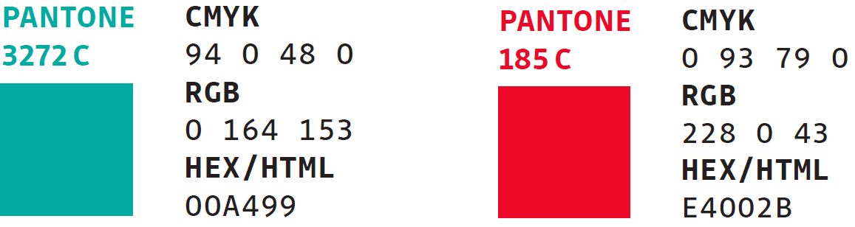
Fig. 1 RGB codes for the colour scheme of the VSB-TUO visual identity.

Objectives of the Dissertation thesis
This section defines the main and specific objectives of the dissertation thesis, which constitute the fundamental framework of the research. The objectives should be formulated clearly and precisely, and they should be derived from the identified problems or gaps in the existing body of knowledge. This chapter may also include the formulation of a research hypothesis or a set of assumptions that the dissertation thesis aims to verify or further develop. The objectives must be consistent with the content of the dissertation thesis and allow for an unambiguous assessment of whether they have been achieved during the course of the research.

Research Methodology
This section describes the methodological approach chosen to address the research problem. It provides an overview of the methods, experimental procedures, models, and analytical tools used to achieve the defined objectives of the dissertation thesis. The description of the methodology is concise, well-structured, and focused on the principles of the applied procedures without unnecessary detail regarding experimental data.
The text also includes a justification for the selection of individual methods, an explanation of their relevance to the research question, and a description of the measures taken to ensure their reliability and reproducibility.

Achieved Results
This chapter summarizes the results and findings obtained so far in the course of the dissertation research. It presents the most important outcomes arising from the conducted experiments, theoretical analyses, or modelling studies that contribute to fulfilling the defined objectives. The results are displayed using graphs, tables, or diagrams that clearly illustrate the key conclusions of the research performed.
The text provides a basic interpretation of the achieved results, emphasizing their significance and their relation to the current state of knowledge in the field. At this stage of the work, the chapter also outlines the anticipated direction of further research and highlights the questions that remain open.

Title of the subchapter
This subchapter provides a clear summary and elaboration of the research results achieved, which are closely related to the defined objectives and the chosen research methodology.
If necessary, the chapter may be further divided into additional subchapters (e.g., 5.1.1, 5.1.2), focusing on specific aspects of the research, theoretical foundations, experimental setup, or data analysis. Each subchapter should be formulated clearly and maintain logical continuity with the preceding parts of the text.

$$f\left(x\right)=a_{0}+\sum_{n=1}^{∞}{\left(a_{n}\cos{\frac{nπx}{L}}+b_{n}\sin{\frac{nπx}{L}}\right)}$$ | (1)
$${\left(x+a\right)}^{n}=\sum_{k=0}^{n}{\left({n \atop k}\right)x^{k}a^{n-k}}$$ | (2)

Tab. 1 Description of the table.

Title of the sub-subchapter
This section provides a more detailed elaboration of a specific aspect of the issue discussed in the preceding subchapter.
The text is written clearly, logically, and factually, with an emphasis on the coherence of the individual parts of the research and on clearly defining the relationships between theory, methodology, and results. All referenced findings, data, equations, and figures are properly cited in accordance with relevant citation standards and accompanied by appropriate source references. The text also incorporates the use of tables, graphs, or illustrations that support the interpretation and facilitate a complete understanding of the presented information.

Title of the subchapter
This subchapter provides a clear summary and elaboration of the research results achieved, which are closely related to the defined objectives and the chosen research methodology.
If necessary, the chapter may be further divided into additional subchapters (e.g., 5.2.1, 5.2.2), focusing on specific aspects of the research, theoretical foundations, experimental setup, or data analysis. Each subchapter should be formulated clearly and maintain logical continuity with the preceding parts of the text.

Title of the sub-subchapter
This section provides a more detailed elaboration of a specific aspect of the issue discussed in the preceding subchapter.
The text is written clearly, logically, and factually, with an emphasis on the coherence of the individual components of the research and on clearly defining the relationships between theory, methodology, and results. All referenced findings, data, equations, and figures are properly cited in accordance with the relevant citation standards and accompanied by appropriate source references. The text also incorporates the use of tables, graphs, or illustrations that support the interpretation and facilitate a comprehensive understanding of the presented information.

Title of the sub-subchapter
This section provides a more detailed elaboration of a specific aspect of the issue discussed in the preceding subchapter.
The text is written clearly, logically, and factually, with an emphasis on the coherence of the individual components of the research and on clearly defining the relationships between theory, methodology, and results. All referenced findings, data, equations, and figures are properly cited in accordance with the relevant citation standards and accompanied by appropriate source references. The text also incorporates the use of tables, graphs, or illustrations that support the interpretation and facilitate a comprehensive understanding of the presented information.

Discussion
The Discussion chapter interprets the achieved results and places them in the context of the current state of knowledge. It provides explanations of the main findings, compares them with relevant scientific literature, and evaluates agreements or discrepancies with previous studies. The chapter also includes an assessment of the contributions and limitations of the conducted research and identifies factors that may influence the interpretation of the results.
Furthermore, the discussion formulates open questions and proposes areas suitable for further research. It also explains how the obtained results fulfil the defined objectives of the dissertation thesis.

Conclusion
The final chapter of the dissertation thesis summarizes the research results and their significance in relation to the defined objectives. This part should contain a comprehensive evaluation of the course and outcomes of the work, a formulation of the main conclusions, and an explanation of how each objective has been fulfilled.
The conclusion should also include a discussion of the obtained findings in the context of the current state of knowledge and identify the contribution of the work to the development of the relevant scientific field. It is essential to highlight the originality and added value of the achieved results and to specify how they can be applied in practice or further developed through future research.
It is also appropriate to formulate recommendations for future research, particularly in areas that have not yet been fully explored or where the results indicate potential for further investigation.
The recommended length of this chapter is 2–4 pages, and the text should be written in a factual, structured, and logically consistent manner, in line with the preceding parts of the dissertation thesis.

Contribution for scientific field
This part of the dissertation thesis summarizes the main contributions of the research to the development of the relevant scientific field. It should clearly formulate new findings, theoretical conclusions, methodological approaches, or experimental results that expand the current state of knowledge and advance the boundaries of the discipline.
The contribution may consist of the formulation of new principles, the improvement of existing methods, the creation of an original model, the design of a new technology, material, or process, or the extension of existing theories with new findings supported by experimental verification.
The text should emphasize the originality and uniqueness of the achieved results, their contribution to the development of fundamental or applied research, and their potential impact on the future direction of scientific progress in the respective field.

Contribution for practice
This part of the dissertation thesis summarizes the practical contributions of the achieved results and their potential applications in industrial, technological, or societal practice. It should describe specific areas in which the research outcomes can be applied, for example, in the development of new materials, optimization of production processes, improvement of environmental technologies, or management of technical systems.
The contribution to practice may consist of the design of a new procedure, technological solution, methodology, or software tool that increases the efficiency or quality of a given process. The results may also contribute to enhancing the competitiveness of industrial enterprises, strengthening the sustainability of production, or facilitating the transfer of scientific knowledge into the application sphere.
It is also appropriate to indicate whether the results of the work have been verified in practice, implemented in a specific industrial setting, or whether they have the potential for further development through collaboration with industrial or research partners.

References
All cited sources (including electronic resources) are listed here in accordance with the ISO 690 standard. Every referenced item must also appear directly in the text of the dissertation thesis, including citations placed under reproduced figures, graphs, or tables, either in square brackets or using the author–year format as specified by ISO 690 (e.g. https://www.iso690.zcu.cz/).

- First citation of the referenced source as indicated in the document.
- Second citation of the referenced source as indicated in the document.
- Third citation of the referenced source as indicated in the document.

List of Own Publications
The conditions for applying for the final state doctoral examination (defence of the dissertation thesis) are defined in the Study and Examination Rules for Doctoral Study Programmes at VSB-TUO (document TUO_VP_07_005, Article 24, Paragraph 4).
The Dean of the Faculty of Materials Science and Technology further specifies these conditions for students of doctoral study programmes in both full-time and part-time forms of study in Directive FMT_SME_22_001, as currently in force.
The list of the author's publications must be compiled in accordance with the ISO 690 citation standard, including consistent formatting of all types of sources (both printed and electronic).

List of Appendices
Appendix A: Description/title of the appendix.
Appendix B: Description/title of the appendix.

(If appendices are part of the dissertation, they must be submitted in a separate document. If the dissertation does not include any appendices, this chapter is not included.)

