

Title of Dissertation thesis

Discussion on the dissertation topic

Author of the thesis: Full name and academic title
Supervisor: Full name and academic titles

Ostrava (year of submission) 

CONTENTS
1 Introduction 2
2 Brief analysis of the current state of knowledge 3
3 Objectives of the dissertation thesis 4
4 Methodology / Research approach 5
5 Expected results and contribution of the dissertation thesis 6
6 Conclusion 7
7 References 8

INTRODUCTION
A concise introduction to the subject area, including justification of the topic selection, its relevance, and its significance.
The structure presented in this template represents a recommended organization of the text. Individual chapters and subchapters may be modified, expanded, or supplemented depending on the nature of the research problem, the focus of the study, or the requirements of the Doctoral studies board.

Brief Analysis of the Current State of Knowledge
This section summarizes the existing results and research directions related to the addressed topic and provides the theoretical framework for formulating the objectives of the dissertation thesis. Particular attention is paid to the analysis of key studies, current trends, and methodological approaches used in the field. The aim is to identify the main findings, unresolved questions, and existing research gaps that have not yet been satisfactorily addressed or sufficiently described in the scientific literature. This analysis also makes it possible to define the scientific context and originality of the planned research, thereby justifying its contribution to the further development of the discipline.

Objectives of the Dissertation thesis
The purpose of this section is to precisely define the main research objective of the dissertation thesis, which determines the fundamental direction and focus of the planned research. The main objective is further elaborated into specific partial objectives that outline the individual steps required for its fulfilment. This chapter also includes the formulation of research questions or hypotheses, which provide a framework for the systematic investigation of the chosen problem and enable the subsequent verification of theoretical assumptions or proposed relationships. The research questions or hypotheses are formulated clearly and unambiguously, directly reflecting the identified gaps in the existing body of knowledge. In doing so, they establish the foundation for the methodological approach and guide the interpretation of the expected results.

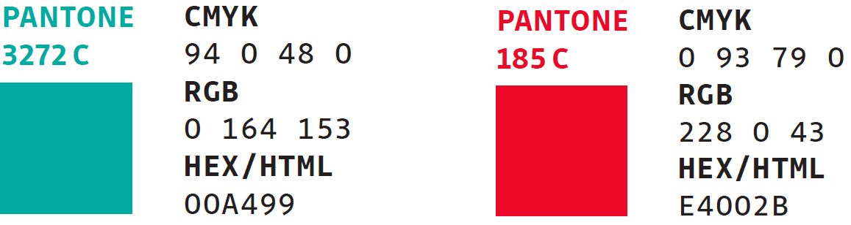
Fig. 1 RGB codes for the colour scheme of the VSB-TUO visual identity.

Methodology / Research Approach
This section presents the methodological framework of the planned research and describes the procedures that will be employed to achieve the defined objectives and to verify the research questions or hypotheses. The methodology includes an overview of the experimental, analytical, theoretical, or modelling approaches that will be applied in the dissertation thesis, along with a justification of their selection in relation to the nature of the investigated problem.
Furthermore, a structured research plan is outlined, including the schedule of the main stages, methods of data collection, and procedures for their processing and interpretation. The methodological approach must be formulated in a way that ensures the reproducibility of the research, provides sufficiently robust foundations for the analysis of results, and guarantees the logical continuity of the individual steps in solving the dissertation task.

$$f\left(x\right)=a_{0}+\sum_{n=1}^{∞}{\left(a_{n}\cos{\frac{nπx}{L}}+b_{n}\sin{\frac{nπx}{L}}\right)}$$ | (1)
$${\left(x+a\right)}^{n}=\sum_{k=0}^{n}{\left({n \atop k}\right)x^{k}a^{n-k}}$$ | (2)

Tab. 1 Description of the table.

Expected Results and Contribution of the dissertation Thesis
This chapter summarizes the expected outcomes of the research and their contribution in both scientific and practical domains. The expected results reflect the defined objectives and research questions and include, in particular, new findings, conclusions, or procedures that advance the understanding of the investigated issue. The expected results may also involve the identification of key mechanisms, the proposal of optimization strategies, or the development of experimental or theoretical models and methodological approaches.
The contribution of the thesis is manifested both scientifically, such as by expanding knowledge in the field or confirming or refuting existing hypotheses, and practically, where the results may support, for example, the development of new materials, the improvement of their functional properties, or the optimization of production and technological processes.

Conclusion
The conclusion of the extended abstract briefly summarizes the main objective of the dissertation thesis, its focus, and its expected contribution. It explains how the proposed research fits into the broader context of scientific knowledge and how it contributes to the development of the field or to the practical application of the results. It also outlines the planned steps for further research, such as the experimental verification of hypotheses, the extension of the theoretical model, or the application of the acquired findings in practice.

References
All cited sources (including electronic resources) are listed here in accordance with the ISO 690 standard. Every referenced item must also appear directly in the text, including citations placed under reproduced figures, graphs, or tables, either in square brackets or using the author–year format as specified by ISO 690 (e.g. https://www.iso690.zcu.cz/).

- First citation of the referenced source as indicated in the document.
- Second citation of the referenced source as indicated in the document.
- Third citation of the referenced source as indicated in the document.

