

Title of Dissertation thesis

Dissertation thesis

Author of the thesis: Full name and academic title
Supervisor: Full name and academic titles

Ostrava (year of submission) 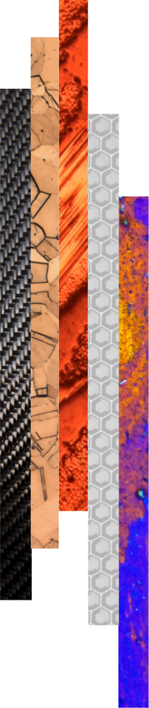

Bibliographic Record
Author: Academic title, first name and surname
Title of the thesis: Title of the Dissertation thesis
Study programme: Code and name of the study programme (e.g. P0413D270001 Industrial Systems Management)
Supervisor: First name and surname, including academic titles
Academic year: 2025/2026
Number of pages:
ANNOTATION OF DISSERTATION THESIS
The abstract provides a concise summary of the main content, objectives, methods, and key findings of the dissertation thesis. It should clearly define the research problem, state the main aim of the work, along with any essential sub-objectives, and briefly describe the methodology or research approach employed. An important part of the abstract is a summary of the most significant results achieved in the dissertation thesis and their scientific, technical, or practical contribution.
The abstract provides a clear and concise overview of the essence of the work, its key findings, and its significance for the field. Its typical length ranges from 150 to 300 words. The text is written succinctly, objectively, and without unnecessary detail.
Keywords: (5-7 keywords)

ACKNOWLEDGEMENTS

CONTENTS
1 Introduction 4
2 Analysis of the current state of knowledge 5
3 Objectives of the dissertation thesis 6
4 Research methodology 7
5 Achieved results 8
5.1 Title of the subchapter 8
5.2 Title of the subchapter 8
5.2.1 Title of the sub-subchapter 9
5.2.2 Title of the sub-subchapter 9
6 Discussion 10
7 Conclusions 11
7.1 Contribution for scientific field 11
7.2 Contribution for practice 11
7.3 Recommendation for further research 11
8 References 13
9 List of own publications 14
10 List of appendices 15

LIST OF ABBREVIATIONS AND SYMBOLS
Symbol | Unit | Description

LIST OF TABLES AND FIGURES
Number | Table/Figure Title | Page

Introduction
This template is designed to facilitate the preparation of the dissertation thesis and to ensure a unified formal layout of final theses at the Faculty of Materials Science and Technology, VSB – Technical University of Ostrava.
The final appearance of the thesis, its structure, formal formatting, and linguistic quality, including the correct use of professional terminology and adherence to grammatical standards, are part of the overall evaluation of the thesis and its defence.
The following text uses the Normal style. If you wish to use left-aligned text without first-line indentation and with spacing between paragraphs, select the Left-aligned Normal style. Hyphenation is not enabled in this template.
The introduction of the dissertation thesis defines the overall framework and research context of the examined issue. It provides a clear justification for the selection of the topic and highlights its relevance within current scientific knowledge or practice. The introduction includes the formulation of the main scientific objective and a concise analysis of existing approaches. It also presents the theoretical foundations on which the dissertation thesis is based and outlines the expected outcomes and scientific contribution of the work.
The structure of the dissertation thesis presented in this template represents a recommended organization of the text. Individual chapters and subchapters may be adjusted, expanded, or supplemented depending on the nature of the topic, research focus, or the requirements of Doctoral studies board.

Analysis of the Current State of Knowledge
This chapter provides an overview of the current state of knowledge in the field addressed by the dissertation thesis, both in the Czech Republic and in the international context. Its aim is to summarize existing theoretical findings, experimental results, and technological approaches published in the scientific literature.
The analysis includes a critical evaluation of previous research, identifying its contributions, limitations, and open questions, thereby defining the space for the doctoral candidate’s own research. Based on these findings, the objectives of the dissertation thesis are clearly formulated and the direction for further research development is established.
The dissertation thesis presents original scientific results or results accepted for publication in scholarly journals or presented at international conferences. These outcomes contribute to the expansion of current knowledge and advance the boundaries of the respective scientific discipline.

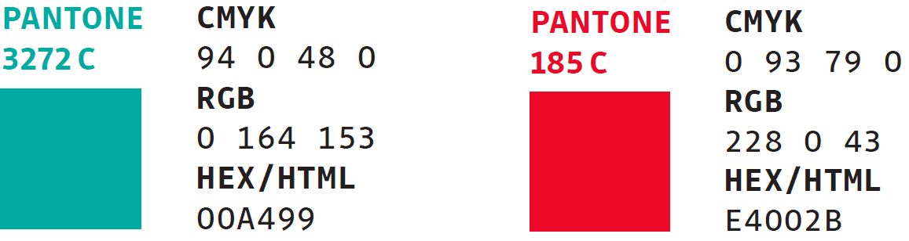
Fig. 1 RGB codes for the colour scheme of the VSB-TUO visual identity.

Objectives of the Dissertation thesis
This chapter defines the main and partial objectives of the dissertation thesis, which determine the direction for addressing the specified scientific and research problem. The objectives should be formulated in a specific, measurable, and logically coherent manner so that their fulfilment can be clearly evaluated in the final part of the thesis.
The achievement of the stated objectives is discussed in the Conclusion chapter, which summarizes the manner in which the objectives were met, evaluates the contributions of the conducted research, and outlines the implications of the obtained results.

Research methodology
The following chapters form the core of the scientific content of the research. The first chapter typically presents the materials and methods used, providing a detailed yet well-structured description of all experimental, analytical, or computational approaches to ensure their reproducibility and clear justification.
The methodological part is followed by a chapter presenting the achieved results. This chapter includes a clear and logically organized overview of the outputs of the experiments or analyses, supplemented with graphs, tables, or illustrations. The emphasis is placed on a concise and comprehensible presentation of key findings without interpretation.
If necessary, additional chapters may be added to ensure that the topic is covered to the required extent and with logical continuity.

Achieved results
This chapter provides a comprehensive summary of the results and findings obtained within the framework of the dissertation research. It presents the key outcomes arising from the conducted experiments, theoretical analyses, or modelling studies that contribute to fulfilling the defined research objectives. The results are displayed using graphs, tables, or diagrams that clearly illustrate the principal findings of the study.
The text focuses on a factual and structured presentation of the achieved results, emphasizing their relevance to the stated objectives and to the methodological approach applied in the research. At this stage, the chapter provides a clear overview of the obtained data and outcomes without in-depth interpretation, which is addressed in the subsequent Discussion chapter.

Title of the subchapter
This section of the dissertation thesis elaborates on another specific aspect related to the research topic. The text should be structured with an emphasis on logical continuity and a clear connection to the overall objectives of the dissertation thesis, while its specific content and scope reflect the needs and focus of the research project.

$$f\left(x\right)=a_{0}+\sum_{n=1}^{∞}{\left(a_{n}\cos{\frac{nπx}{L}}+b_{n}\sin{\frac{nπx}{L}}\right)}$$ | (1)
$${\left(x+a\right)}^{n}=\sum_{k=0}^{n}{\left({n \atop k}\right)x^{k}a^{n-k}}$$ | (2)

Tab. 1 Description of the table.

Title of the subchapter
This part of the dissertation thesis provides a more detailed elaboration of a selected research area that is closely connected to the objectives and methodology of the study. The text should include a description of the principles, approaches, and procedures employed in addressing the given issue.
If necessary, the chapter may be further divided into subchapters (e.g., 4.2.1, 4.2.2) that focus on specific aspects of the research, theoretical foundations, experimental setup, or data analysis. Each subchapter should be clearly formulated and logically connected to the preceding part of the text.

Title of the sub-subchapter
This section provides a more detailed elaboration of a specific aspect of the issue discussed in the preceding subchapter.
The text should be written in a clear, logical, and factual manner, with an emphasis on the continuity of the individual research components and a coherent explanation of the relationships between theory, methodology, and results. All referenced findings, data, equations, and figures must be properly cited in accordance with citation standards and accompanied by appropriate source references. It is also advisable to use tables, graphs, or illustrations that support the interpretation and facilitate a comprehensive understanding of the presented information.

Title of the sub-subchapter
This section provides a more detailed elaboration of a specific aspect of the issue discussed in the preceding subchapter.
The text should be written in a clear, logical, and factual manner, with an emphasis on the continuity of the individual research components and a coherent explanation of the relationships between theory, methodology, and results. All referenced findings, data, equations, and figures must be properly cited in accordance with citation standards and accompanied by appropriate source references. It is also advisable to use tables, graphs, or illustrations that support the interpretation and facilitate a comprehensive understanding of the presented information.

Discussion
This chapter represents a crucial part of the dissertation, as it interprets the obtained results in the context of the current state of knowledge and situates them within the broader framework of relevant scientific literature. The discussion provides a critical evaluation of the acquired data, compares them with previously published findings, and identifies both consistencies and discrepancies arising from the conducted research. Particular attention is devoted to explaining the observed trends, mechanisms, and phenomena that emerged during the experimental work and clarifying their significance for the addressed research problem.
An integral part of this chapter is also the analysis of the limitations of the experimental methods and technological procedures used, including the identification of potential sources of uncertainty and factors that may have influenced the interpretation of the results. This critical assessment enables an objective evaluation of the reliability and validity of the conclusions drawn.
The discussion further defines the practical and theoretical implications of the research, highlights its contribution to the advancement of knowledge in the given field, and relates the obtained results to the stated objectives of the dissertation. This chapter also outlines relevant implications for future research, technological practice, and industrial applications.
Given its character and function, this chapter constitutes one of the most important parts of the dissertation. Its thorough elaboration is essential for a comprehensive understanding of the significance of the achieved results and for their proper interpretation within the context of contemporary scientific and research practice..

Conclusions
This chapter provides a clear and concise summary of the achieved results of the dissertation thesis and their fulfilment in relation to the defined objectives. The introduction of the chapter presents a brief overview of the main findings, followed by a structured list of key conclusions, ideally in the form of bullet points.
The recommended length of the chapter is 2–4 pages, and the text is written in a factual, structured manner, maintaining logical continuity with the preceding parts of the dissertation thesis.

Contribution for scientific field
This section of the dissertation thesis summarizes the main contributions of the research to the development of the relevant scientific field. It clearly formulates new findings, theoretical conclusions, methodological approaches, or experimental results that extend the current state of knowledge and advance the boundaries of the discipline.
The contribution lies in formulating new principles, improving existing methods, creating an original model, proposing a new technology, material, or procedure, or supplementing existing theories with new experimentally validated insights.
The text emphasizes the originality and uniqueness of the achieved results, their contribution to the development of basic or applied research, and their potential impact on further scientific progress in the field.

Contribution for practice
This section of the dissertation thesis summarizes the practical benefits of the achieved results and their potential application in industrial, technological, or societal practice. It describes specific areas in which the research outcomes can be applied, for example, in the development of new materials, optimization of manufacturing processes, improvement of environmental technologies, or control of technical systems.
The contribution to practice lies in proposing a new procedure, technological solution, methodology, or software tool that enhances or improves a given process. The results also contribute to increasing the competitiveness of industrial enterprises, strengthening the sustainability of production, and transferring scientific knowledge into the application sphere.
This section also includes information on whether the results have been verified in practice, implemented in an operational setting, or whether they have potential for further development through collaboration with industrial or research partners.

Recommendation for further research
This section presents proposals and recommendations for the further development of research in the area under investigation. Based on the achieved results, it identifies directions that require deeper analysis, verification, or expansion of the research through new approaches, methods, or technologies.

References
All cited sources (including electronic resources) are listed here in accordance with the ISO 690 standard. Every referenced item must also appear directly in the text of the dissertation thesis, including citations placed under reproduced figures, graphs, or tables, either in square brackets or using the author–year format as specified by ISO 690 (e.g. https://www.iso690.zcu.cz/).

- First citation of the referenced source as indicated in the document.
- Second citation of the referenced source as indicated in the document.
- Third citation of the referenced source as indicated in the document.

List of Own Publications
The conditions for applying for the final state doctoral examination (defence of the dissertation thesis) are defined in the Study and Examination Rules for Doctoral Study Programmes at VSB-TUO (document TUO_VP_07_005, Article 24, Paragraph 4).
The Dean of the Faculty of Materials Science and Technology further specifies these conditions for students of doctoral study programmes in both full-time and part-time forms of study in Directive FMT_SME_22_001, as currently in force.
The list of the author's publications must be compiled in accordance with the ISO 690 citation standard, including consistent formatting of all types of sources (both printed and electronic).

List of Appendices
Appendix A: Description/title of the appendix.
Appendix B: Description/title of the appendix.

(If appendices are part of the dissertation, they must be submitted in a separate document. If the dissertation does not include any appendices, this chapter is not included.)

