

Title of Master’s thesis

Master’s thesis

Author of the thesis: Full name
Supervisor: Full name and academic titles

Ostrava (year of submission) 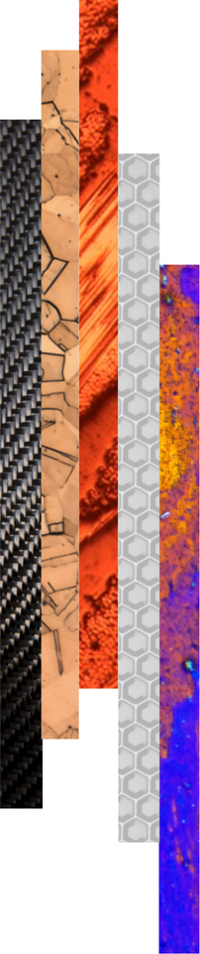

Bibliographic Record
Author: Academic title, first name and surname
Title of the thesis: Title of the Master’s thesis
Study programme: Code and name of the study programme (e.g. N0715A270005 Advanced Engineering Materials)
Supervisor: First name and surname, including academic titles
Academic year: 2025/2026
Number of pages:
(PLACE FOR THE MASTER’S THESIS ASSIGNMENT – DELETE THIS TEXT)

ACKNOWLEDGEMENTS

ABSTRACT
The abstract provides a concise summary of the main content, objectives, methods, and achieved results of the master’s thesis. It clearly defines the problem addressed, states the main aim of the thesis, and, where relevant, outlines key sub-objectives. It briefly describes the methodology, the chosen approach, or the experimental procedures used to achieve the defined goals.
The abstract also summarizes the most important findings and outcomes of the thesis, highlighting their practical, technical, or theoretical contribution. It offers a quick and clear overview of the essence of the work, its main conclusions, and its relevance to the field.
The typical length of the abstract is 80–100 words. The text is concise, factual, and does not include unnecessary detail.
Keywords: (4-5 keywords)

CONTENT
1 Introduction 4
2 Analysis of the current state of knowledge 5
3 Objectives of the master’s thesis 6
4 Title of the first chapter 7
4.1 Title of the subchapter 7
4.2 Title of the subchapter 7
4.2.1 Title of the sub-subchapter 7
4.2.2 Title of the sub-subchapter 8
5 Discussion 9
6 Conclusion 10
7 References 11
8 List of appendices 12

LIST OF ABBREVIATIONS AND SYMBOLS
Symbol | Unit | Description

LIST OF TABLES AND FIGURES
Number | Table/Figure Title | Page

INTRODUCTION
This template is designed to facilitate the preparation of a master’s thesis and to ensure a uniform formal layout of final theses at the Faculty of Materials Science and Technology, VSB – Technical University of Ostrava. The final appearance of the thesis, including its structure, formatting, and linguistic quality, as well as the correct use of professional terminology and adherence to grammatical standards, forms an integral part of the overall assessment of the master’s thesis and its defence. The master’s thesis must be prepared with a minimum length of 45 pages. The requirements for the preparation of the master’s thesis are specified in the Guidelines for the preparation of the master’s thesis, which are available on the FMT website under Study regulations and forms.
The following text uses the Normal style. If left-aligned text without first-line indentation and with spacing between paragraphs is preferred, the Left-aligned Normal style may be used. Hyphenation is not enabled in this template.
The introduction of the master’s thesis defines the overall framework and academic context of the addressed topic. It provides a clear justification for selecting the topic and highlights its relevance in terms of the current state of knowledge or practice. The introduction includes the formulation of the main objective of the thesis and a concise overview of existing approaches or relevant findings in the field. It also presents the theoretical foundations on which the thesis is built and outlines the expected results and contribution of the work to the addressed topic or to practical applications.
The structure of the master’s thesis provided in this template represents a recommended organisation of the text. Individual chapters and subchapters may be modified, expanded, or supplemented depending on the nature of the topic.

ANALYSIS OF THE CURRENT STATE OF KNOWLEDGE
This chapter summarizes the fundamental knowledge and information available on the topic addressed in the bachelor’s thesis and thus provides a literature review of relevant sources. It focuses on an overview of theoretical concepts, published studies, and practical approaches related to the researched issue.
The chapter also includes a brief analysis of existing approaches and their contributions or limitations. This analysis helps to define the scope of the investigated problem and shows the context in which the subsequent work will be carried out.
This part serves as the theoretical foundation for the practical or analytical section of the bachelor’s thesis and enables the subsequent results and conclusions to be placed within a broader academic context.
Figures, tables, charts, and equations must be numbered consistently and clearly throughout the thesis. Each of these elements must be accompanied by an appropriate description (caption, title, or legend) to ensure their unambiguous identification in the text. Recommended formatting for tables, figures, and equations is provided below.

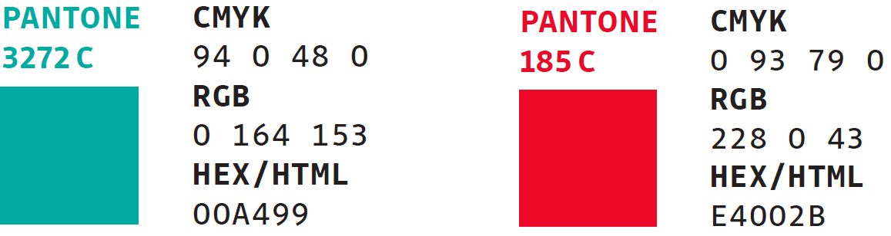
Obr. 1 RGB codes for the colour scheme of the VSB-TUO visual identity.

$$f\left(x\right)=a_{0}+\sum_{n=1}^{∞}{\left(a_{n}\cos{\frac{nπx}{L}}+b_{n}\sin{\frac{nπx}{L}}\right)}$$ | (1)
$${\left(x+a\right)}^{n}=\sum_{k=0}^{n}{\left({n \atop k}\right)x^{k}a^{n-k}}$$ | (2)

Tab. 1 Description of the table.

Objectives of the Master’s Thesis
This chapter formulates the main and, where applicable, partial objectives of the master’s thesis, which define the direction for addressing the assigned topic. The objectives are stated clearly, specifically, and logically to allow for an unambiguous evaluation of their fulfilment. The main objective expresses the overall focus and expected outcome of the thesis, while the partial objectives represent the individual steps or stages required to achieve it.

TITLE OF THE FIRST CHAPTER
The following chapters constitute the main technical and scholarly part of the master´s thesis. The first chapter typically describes the materials and methods used, providing a clear overview of the selected procedures, experimental techniques, analytical methods, or computational tools applied to address the given problem.
The methodological section is followed by a chapter presenting the results achieved. This part contains logically structured outputs of the experiments or analyses, supplemented with appropriate graphs, tables, or figures that clearly illustrate the main findings.
If necessary, additional subchapters may be included to ensure that the topic is covered with appropriate scope and coherence.

Title of the subchapter
This part of the master´s thesis elaborates on another specific aspect related to the addressed topic. The text should be structured with an emphasis on logical continuity and a clear connection to the overall objectives of the thesis, while its specific content and scope reflect the nature of the topic and the chosen approach to its solution.

Title of the subchapter
This part of the master´s thesis provides a more detailed elaboration of a selected area related to the topic, closely linked to the objectives and the chosen methodology. The text should include a description of the principles, approaches, and procedures applied in addressing the given issue.
If necessary, the chapter may be further divided into subchapters (e.g., 4.2.1, 4.2.2), focusing on specific aspects of the topic, theoretical foundations, experimental setup, or data analysis. Each subchapter should be written clearly and maintain logical continuity with the preceding part of the text.

Title of the sub-subchapter
This section provides a more detailed elaboration of a specific aspect of the topic discussed in the preceding subchapter.
The text should be written clearly, logically, and factually, with an emphasis on the coherence of the individual parts of the thesis and on clearly explaining the relationships between the theoretical background, the chosen methodology, and the obtained results. All referenced findings, data, equations, and figures must be properly cited in accordance with citation standards and accompanied by appropriate source references. It is also advisable to use tables, graphs, or illustrations that support the interpretation and facilitate a comprehensive understanding of the presented information.

Title of the sub-subchapter
This section provides a more detailed elaboration of a specific aspect of the topic discussed in the preceding subchapter.
The text should be written clearly, logically, and factually, with an emphasis on the coherence of the individual parts of the thesis and on clearly explaining the relationships between the theoretical background, the chosen methodology, and the obtained results. All referenced findings, data, equations, and figures must be properly cited in accordance with citation standards and accompanied by appropriate source references. It is also advisable to use tables, graphs, or illustrations that support the interpretation and facilitate a comprehensive understanding of the presented information.

Discussion
This chapter interprets the achieved results and places them within the context of current knowledge in the field. It includes an evaluation of the obtained data, their comparison with relevant academic literature, and an explanation of the main trends or phenomena emerging from the results. The discussion focuses on clarifying the significance of the findings for the addressed topic.
This chapter also includes a brief evaluation of the methods used, potential limitations of the data, and factors that may have influenced the interpretation of the results. Furthermore, the discussion explains how the findings relate to the defined objectives of the master’s thesis and outlines their practical or academic relevance.

Conclusion
This chapter provides a concise and clear summary of the main results of the master’s thesis and evaluates the extent to which they fulfil the defined objectives. The introductory part of the chapter offers a brief overview of the most important findings, followed by a structured presentation of the key conclusions derived from the conducted work.
The chapter also includes an evaluation of the contribution of the results to the relevant field or to practical applications, as well as to the further development of the addressed issue. The text is written in a factual and well-structured manner and follows logically from the preceding chapters, providing a comprehensive assessment of the significance of the achieved findings.

REFERENCES
All cited sources (including electronic resources) are listed here in accordance with the ISO 690 standard. Every referenced item must also appear directly in the text, including citations placed under reproduced figures, graphs, or tables, either in square brackets or using the author–year format as specified by ISO 690 (e.g. https://www.iso690.zcu.cz/).
The master´s thesis must include at least 15 bibliographic references, of which a minimum of 3 must be in a foreign (world) language.

- First citation of the referenced source as indicated in the document.
- Second citation of the referenced source as indicated in the document.
- Third citation of the referenced source as indicated in the document.

List of Appendices
Appendix A: Description/title of the appendix.
Appendix B: Description/title of the appendix.

(If appendices are part of the dissertation, they must be submitted in a separate document. If the dissertation does not include any appendices, this chapter is not included.)

